Peter Julius M. Estacio
Grouped with:
Niño Aloysius V. De Mesa
Christian James S. Madariaga
ENGG 151.01-A
March 15, 2026

Self-Evaluation for Project 2: Fourier Transform

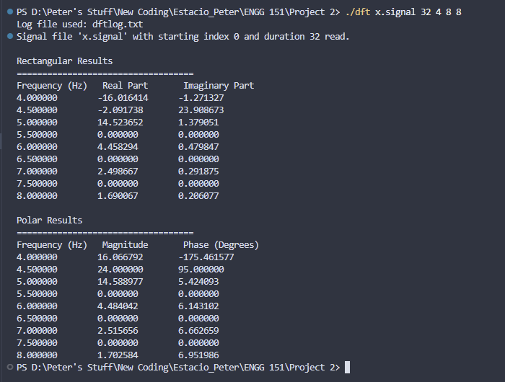
sample screenshot – executable main run and displaying results of main program

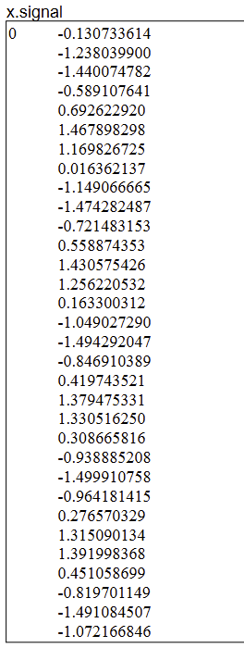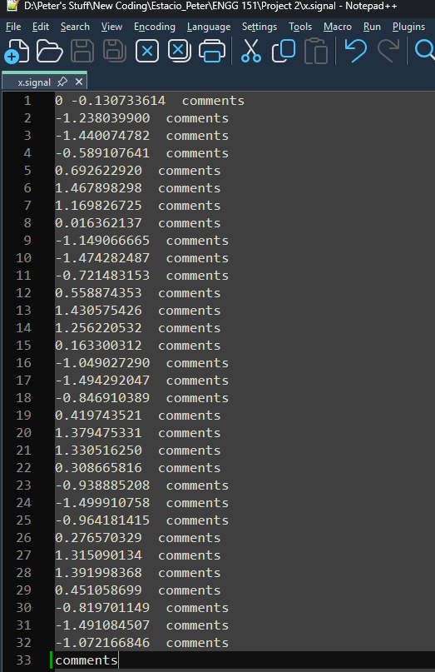
sample screenshots – comparison between basic test signal and input signal file used in program
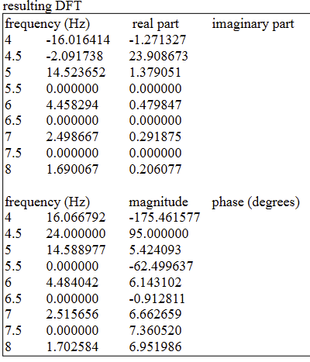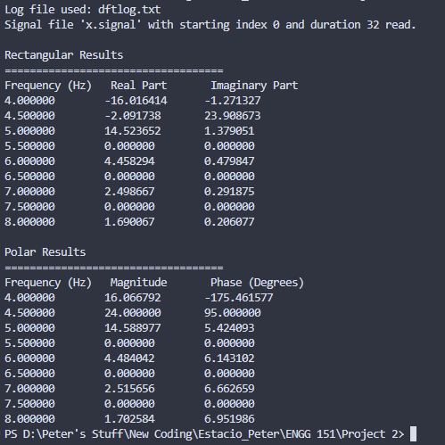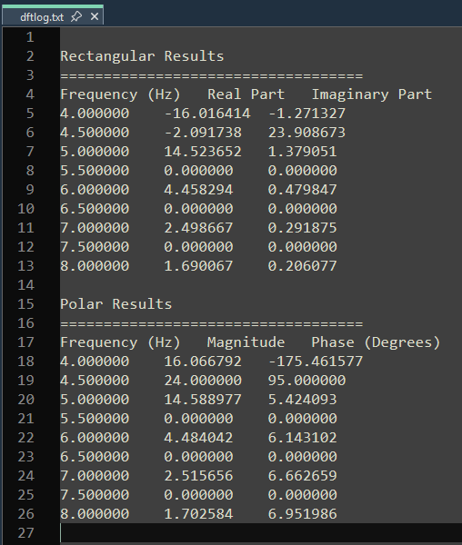
sample screenshots – comparison between basic test results, console output, and program output file

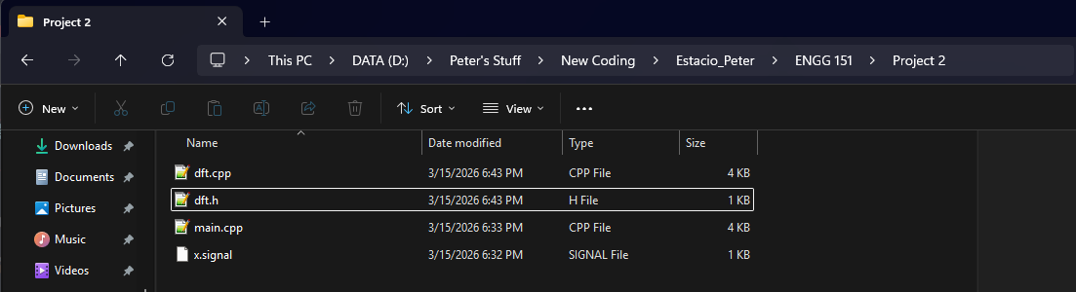
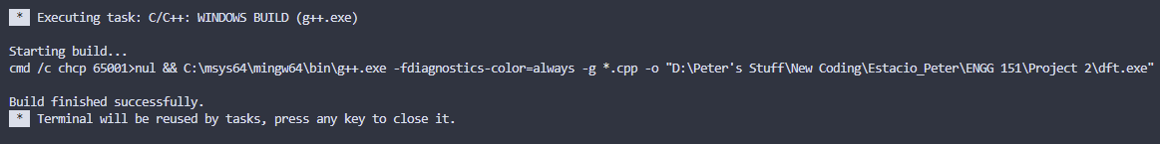
sample screenshot – compilation on Visual Studio Code with directory files
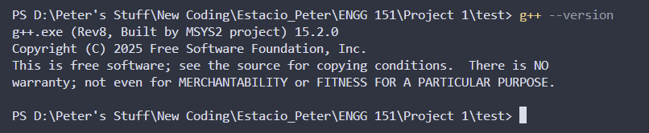
compiler version – g++ version 15.2.0 (Rev8, Built by MSYS2 project)
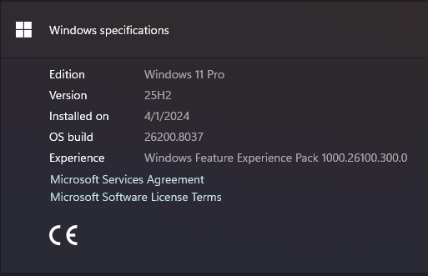
operating system - Windows 11 Pro, 25H2, build 26200.8037
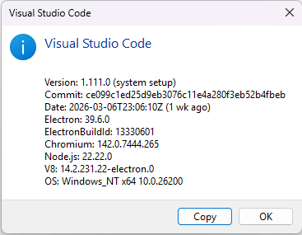
IDE – Visual Studio Code ver 1.111.0
Code Locator:
code items | file name | line numbers
DFT function | dft.cpp | 113-144
declaration of double * that are passed to the DFT function | main.cpp | 43-47
separate processing of first line of signal file | dft.cpp | 61-84
input validation of integers in processing signal files | dft.cpp | 10-25
input validation of floating point numbers in processing signal files | dft.cpp | 27-42

Project Evaluation - Fourier Transform
Item | Points | Rubrics
early work | 8/8 | (all or nothing)  8: at most 10% of the code in the final implementation differs from that in early work submission
implementation and testing environment report | 4/4 | 4 - all instructions followed correctly
basic test | 50/50 | 50 - correctly computes the DFT of basic test data
 | 6/6 | 6 - screenshot submitted showing the correctly computed DFT of basic test data as it appears on the console output
generality of DFT | 6/6 | 6 - the DFT is computed correctly and efficiently at all times
DFT function | 6/6 | 6 - the DFT is computed correctly and efficiently at all times, by a function as specified
processing of signal files | 4/4 | 4 - The file is opened only once and the first line of the signal file is processed correctly and separately from code processing the rest of the signal file
input validation | 4/4 | 4 - integers and floating point numbers are fully validated when signal files are processed
command line | 4/4 | 4 - application processes command line arguments correctly at all times
application feedback | 4/4 | 4 - application produces required outputs and provides appropriate feedback at all times, as specified
self-evaluation | 4/4 | 4 - self-evaluation accurate (or evaluating this item leads to an error)
total | 100/100

